WAN HAI 503 (旺春輪)事故說明 2025.6.9 新聞公告

萬海航運在6月9日發布重大訊息：:WAN HAI 503 (旺春輪)在印度西岸外海失火事故，公司正在與主管機關和保險公司積極合作，處理後續的船員救助、貨物保全以及船舶救援評估等事項。(參考網站https://mopsov.twse.com.tw/mops/web/t05sr01_1 股票代號:2615)
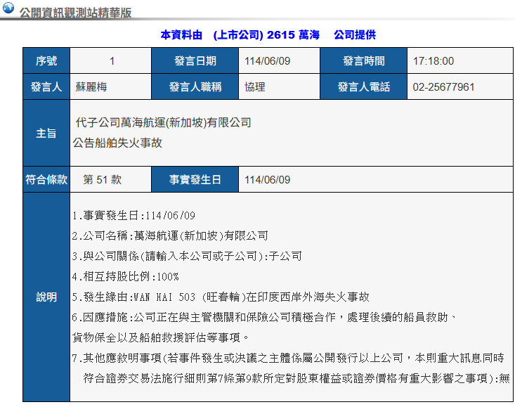

日期：2025年6月9日
主題：萬海航運關於WAN HAI 503 旺春輪船上失火事故說明
本公司所營運之WAN HAI 503 旺春輪於台北時間2025年6月9日在印度西岸航行期間，船上發現濃煙並報告失火。火災的具體原因仍需進一步釐清。公司已立即啟動緊急應變小組, 並迅速與船上人員、主管機關和保險公司合作, 執行緊急處理程序. 經過船長與印度當地海事單位公司的綜合評估，為確保全體船員人身安全，我們依照國際海事規範執行棄船程序。
船上共計22名船員，其中4名船員失蹤，此外18名船員(含5名受傷船員)已安全撤離，在相關單位協助下，這些船員將被妥善安排及接受必要的醫療服務。

目前，公司正在與主管機關和保險公司積極合作，處理後續的船員救助、貨物保全以及船舶救援評估等事項。若有進一步信息，我們將會及時更新告知。極合作，處理後續的船員救助、貨物保全以及船舶救援評估等事項。若有進一步信息，我們將會及時更新告知。

Note: The following English text is a translation of the official Chinese statement dated June 9, 2025.

Wan Hai Lines - Statement on Fire Incident Aboard WAN HAI 503 Vessel

Wan Hai Lines released important news on June 9: Onboard fire on the vessel WAN HAI 503 near southwest of the Indian coastline. Wan Hai is actively cooperating with relevant authorities and insurance providers to handle subsequent matters including crew rescue, cargo preservation, and assessment of salvage operations. (https://emops.twse.com.tw/server-java/t58query Quick Search : 2615)
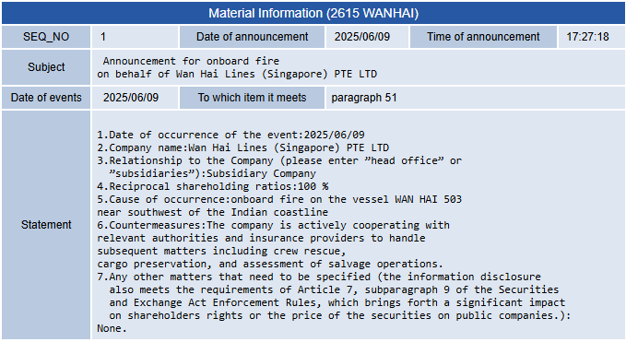

Date: June 9, 2025
Subject: Statement on Fire Incident Aboard WAN HAI 503 Vessel

The WAN HAI 503 (Chinese name: "Wan Chun Lun"), operated by our company, reported a fire on board during its voyage off the west coast of India on June 9, 2025 (Taipei time), after detecting thick smoke. The exact cause of the fire remains under investigation.

Wan Hai immediately activated its emergency response team and swiftly coordinated with the crew on board, relevant authorities, and insurance providers to carry out emergency response procedures.

Following a joint assessment by the vessel’s master and Indian maritime authorities, and in accordance with international maritime regulations, an order to abandon ship was issued to ensure the safety of all crew members.

There were 22 crew members on board. Of these, 4 have been reported missing. The remaining 18 crew members, including 5 injured, have been safely evacuated. With the assistance of relevant agencies, appropriate accommodations and necessary medical care are being arranged for them.

At present, the company is actively cooperating with the authorities and insurance providers to carry out search and rescue operations, secure cargo, and evaluate salvage plans for the vessel.

Further updates will be provided as new information becomes available.

